STREAMLINIG TICKET ASSIGNMENT FOR EFFICIENT SUPPORT OPERATIONS

Team ID : NM2025TMID17214

Team Members : 4

Team Leader : DIVYASRI.G

Team Member 1 : JANANI.S

Team Member 2 : KAVITHA.K

Team Member 3 : MONESHWARI.A

**Project statement :**

This project focuses on streamlining ticket assignment to ensure efficient support operations by automating prioritization, balancing workloads across teams, and reducing resolution time, ultimately improving customer satisfaction and service quality.

**Objective :**

To design and implement an automated ticket assignment system that reduces ticket resolutions time by 30% and increases customer satisfaction rating by 25% through efficient support operations.

**Skills :**

Workflow automation

Ticketing system management(like ServiceNow)

Data analysis optimizing ticket assignment

**TASK INITIATION**

**1.Create Users**

1. Open service now.
2. Click on All >>search for users
3. Select Users under system security
4. Click on new
5. Fill the following details to create a new user

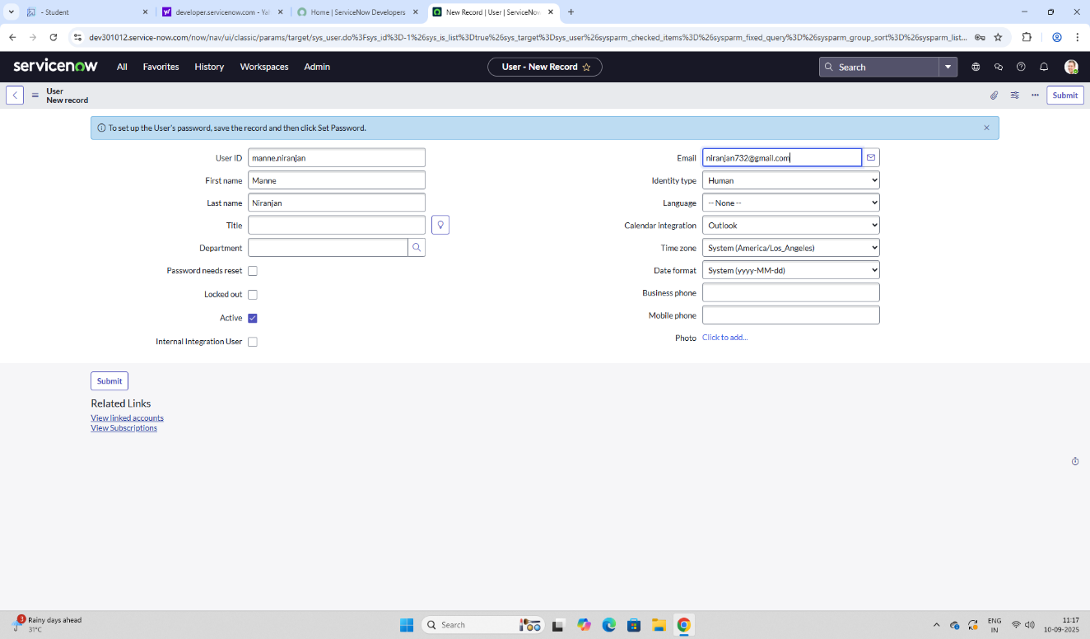

1. Click on submit

Create one more user:

1. Create another user with the following details

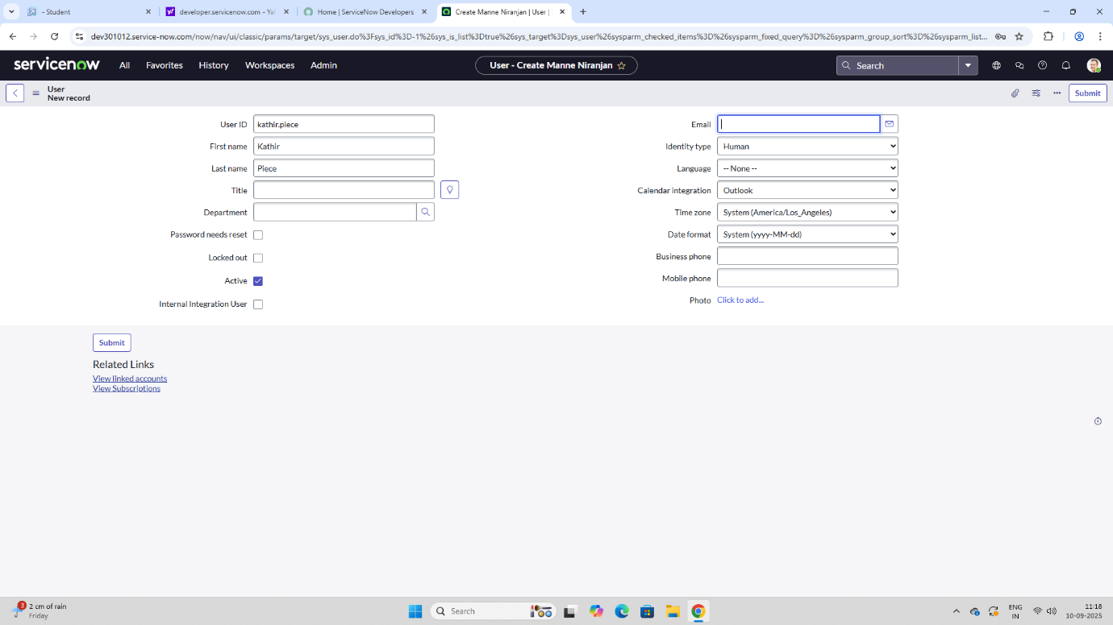

1. Click on submit.

**2. Create Groups**

1. Open service now.
2. Click on All >>search for groups
3. Click on new
4. Fill the following details to create a new group

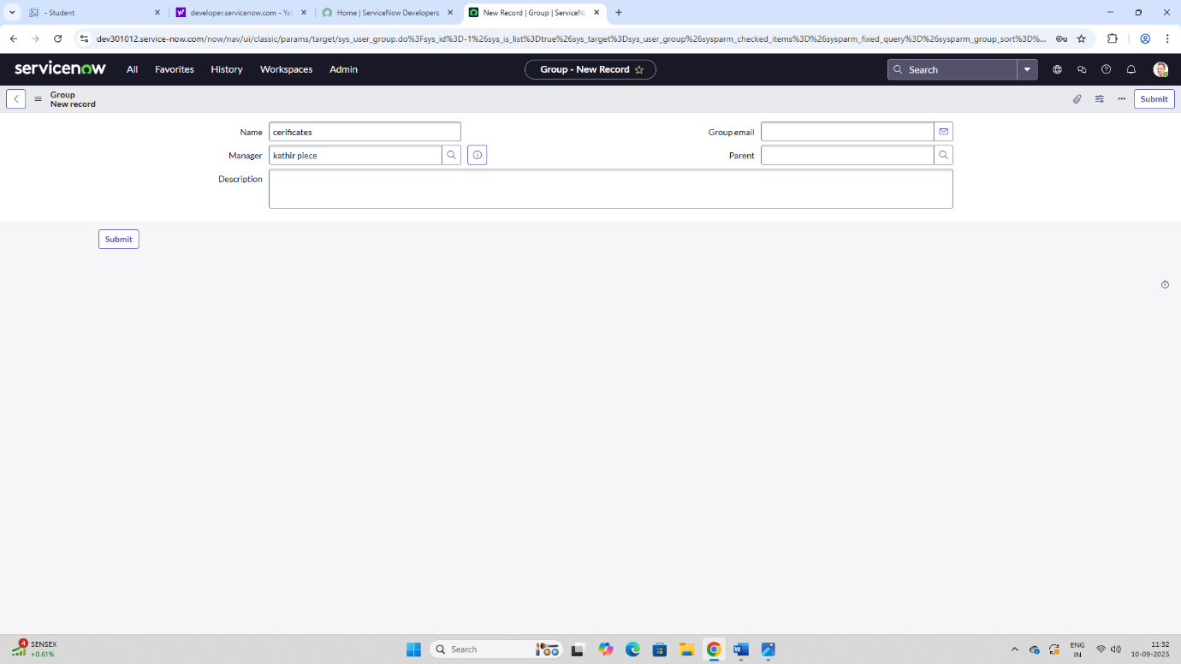

1. Click on submit.

Create one more group:

1. Create another group with the following details

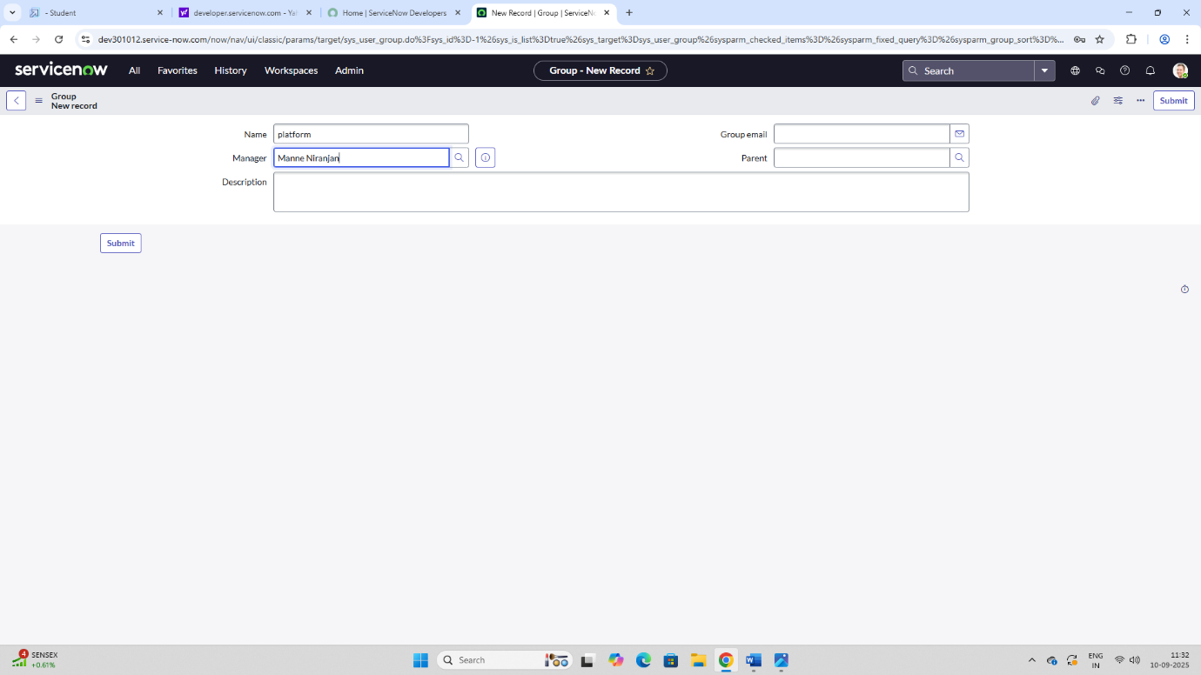

1. Click on submit.

**3.Create Roles**

1. Open service now.
2. Click on All >>search for roles
3. Select roles under system security
4. Click on new
5. Fill the following details to create a new role

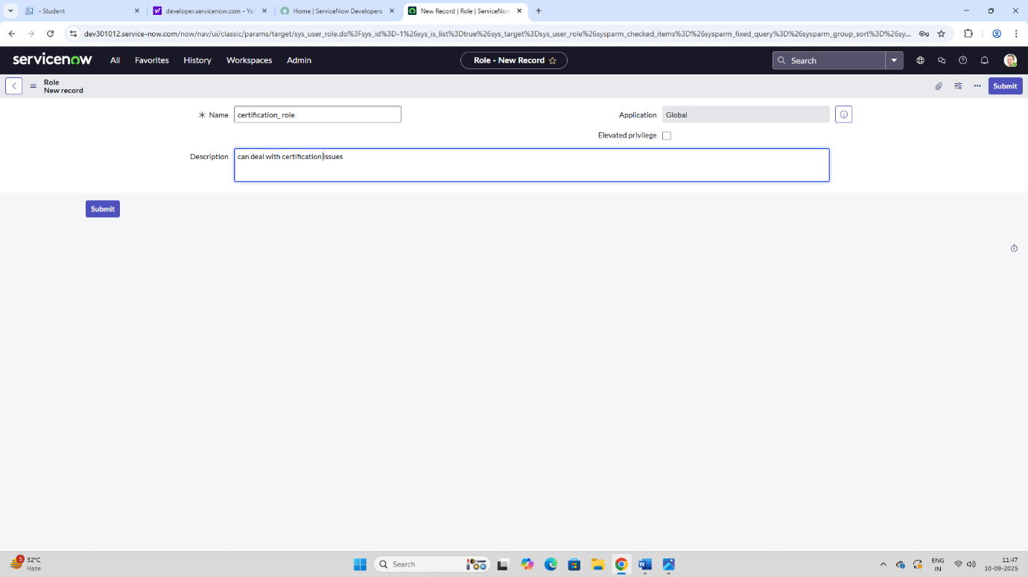

1. Click on submit

Create one more role:

Create another role with the following details

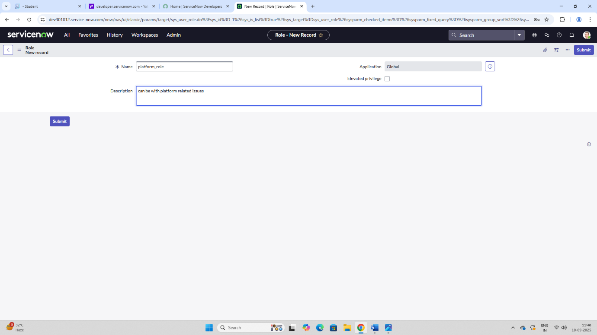

1. Click on submit

**4.Create Table**

1. Open service now.
2. Click on All >>search for tables
3. Select tables under system definition
4. Click on new
5. Fill the following details to create a new table

Label: Operations related

Check the boxes create module & create mobile module

1. Under new menu name: Operations related
2. Under table columns give the columns

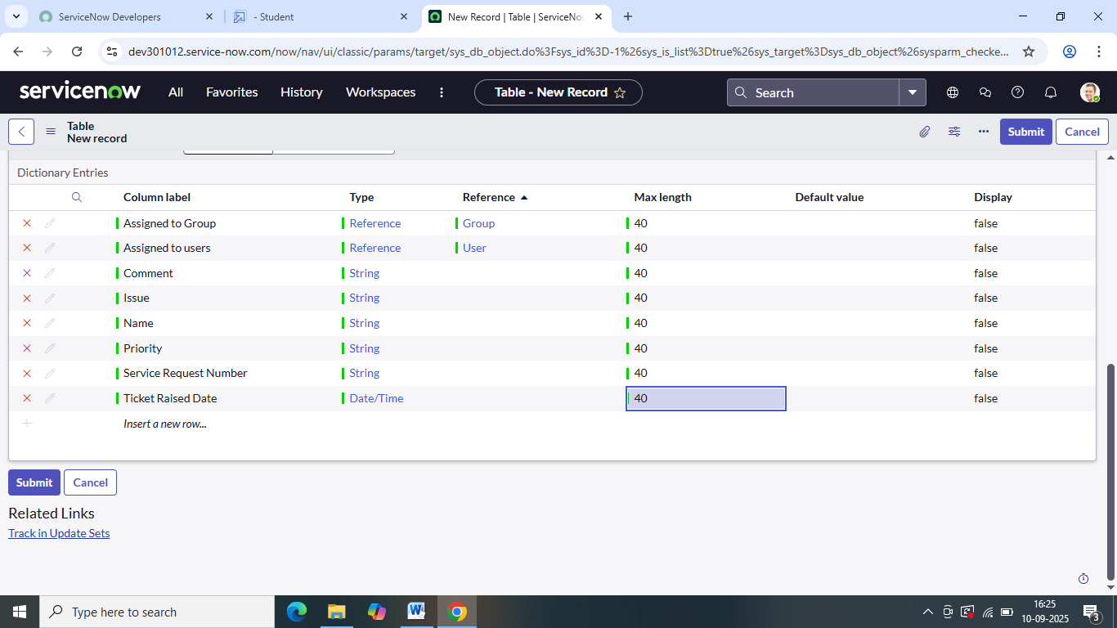

1. Click on submit

Create choices for the issue filed by using from design choices are

* Unable to login to platform
* 404 error
* Regarding certificates
* Regarding user expired

**5.Assign roles & users to certificate group**

1. Open service now.
2. Click on All >>search for tables
3. Select tables under system definition
4. Select the certificates group
5. Under group members
6. Click on edit
7. Select Katherine pierce and save
8. Click on roles
9. Select certification role and save

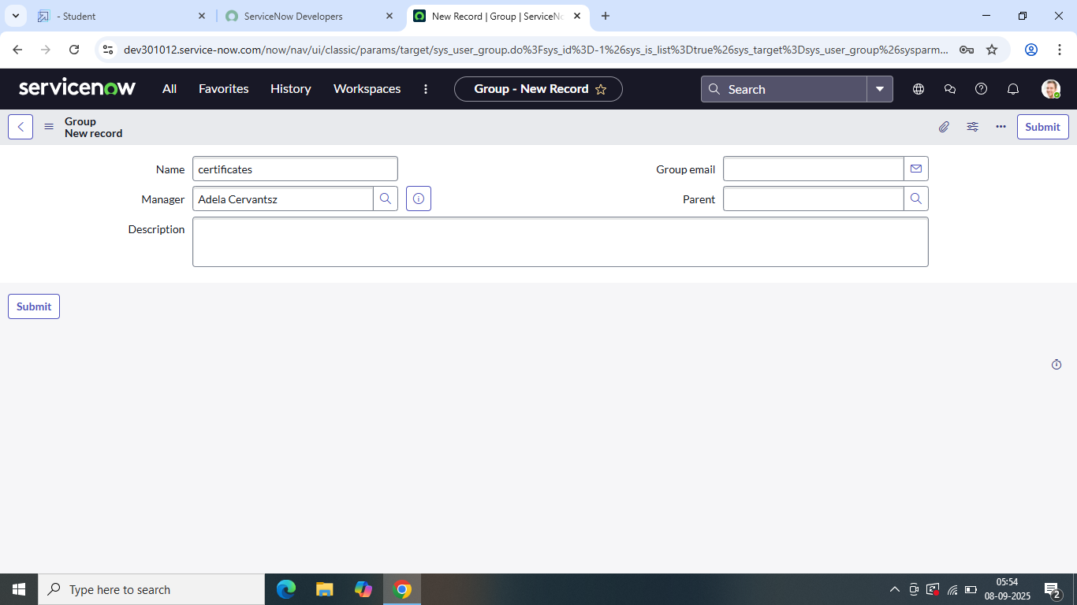

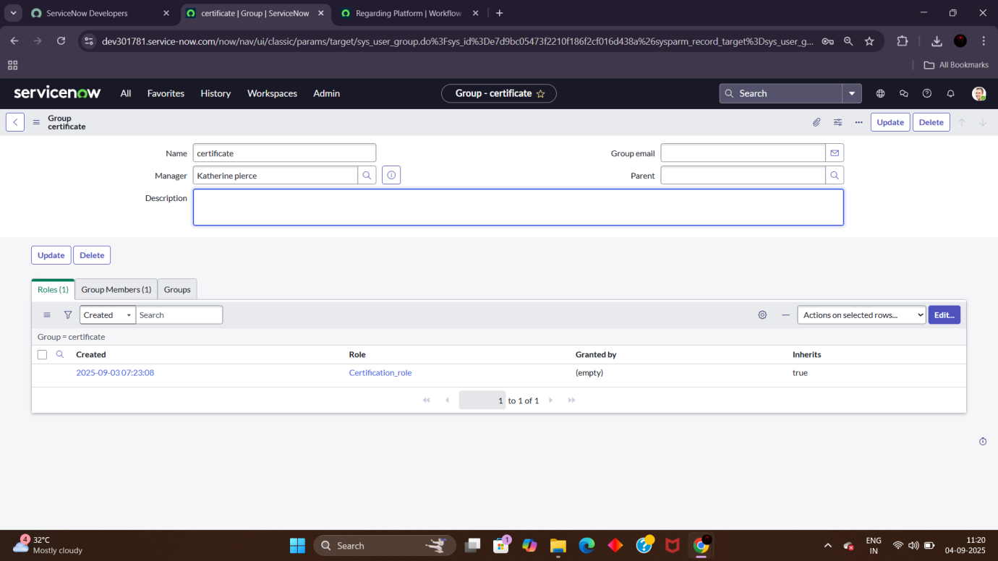

**6.Assignroles &user to platform group**

1. Open service now.
2. Click on All >>search for tables
3. Select tables under system definition
4. Select the platform group
5. Under group members
6. Click on edit
7. Select Manne Niranjanand save

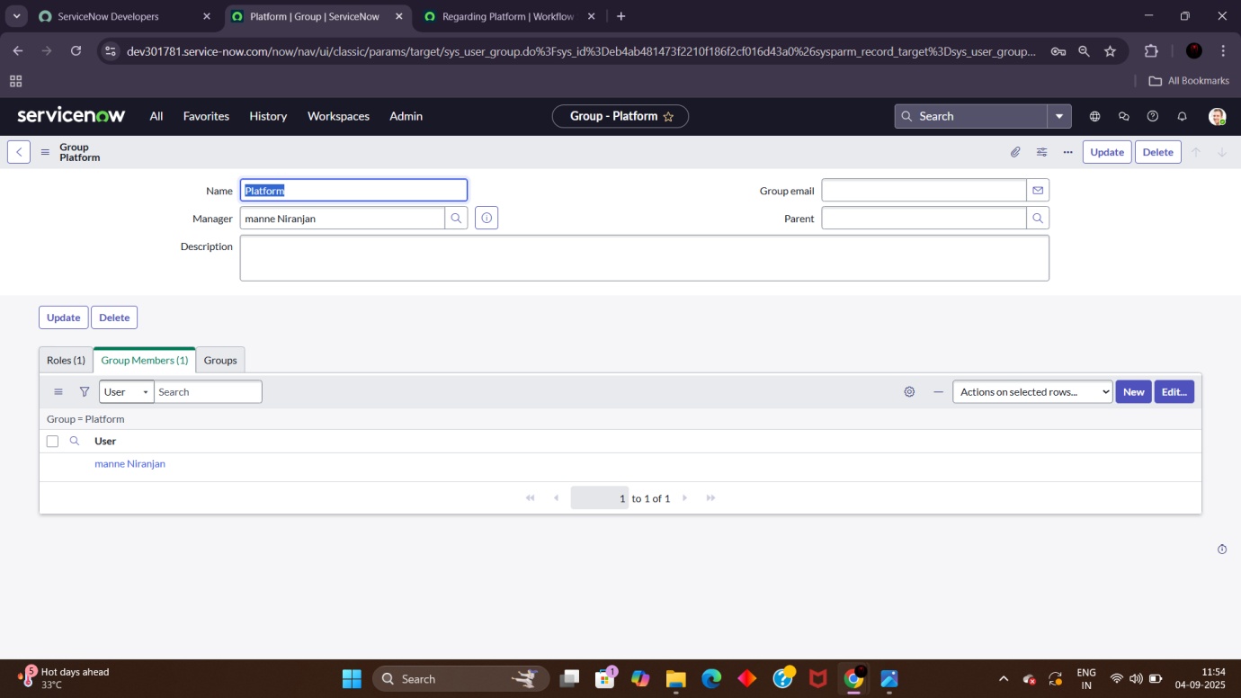

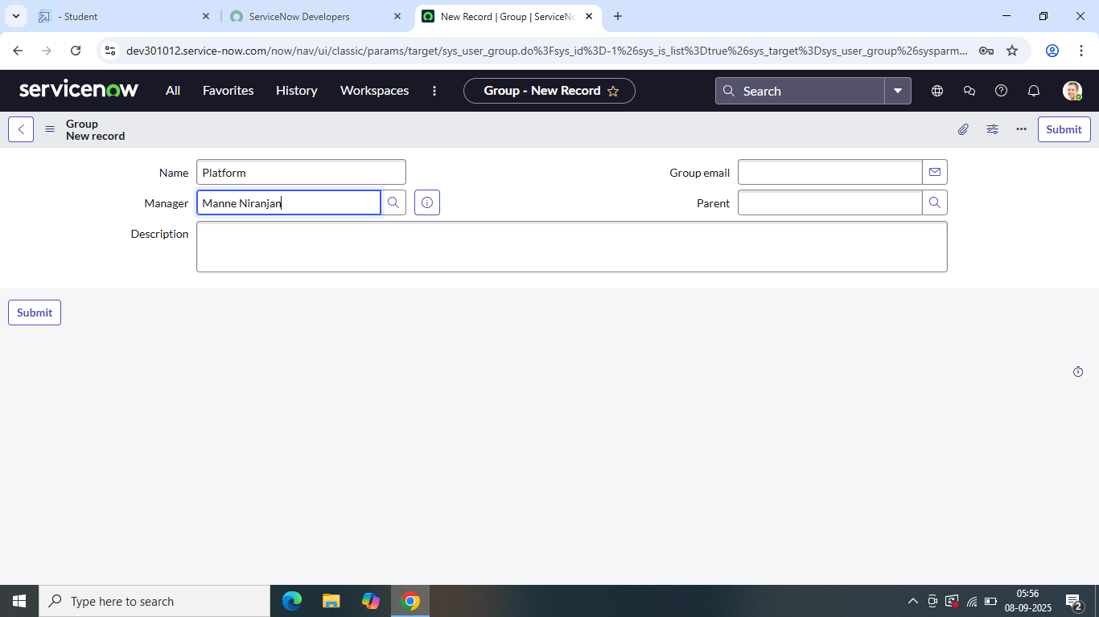

**7.Assign role to table**

1. Open service now.
2. Click on All >> search for tables
3. Select operation related tables

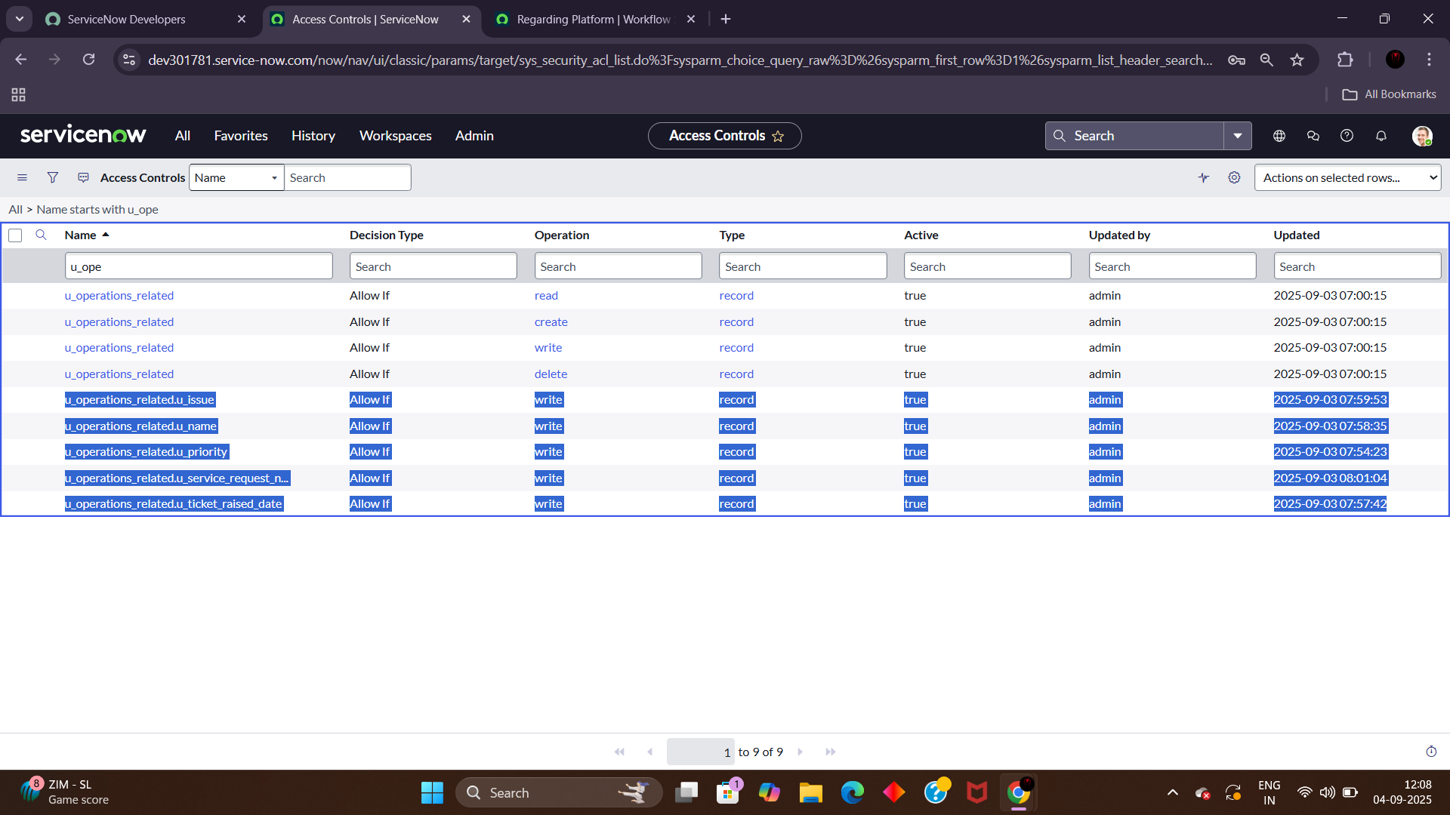

1. Click on the applications accesses
2. Click on u_operations_ related read operations
3. Click on the profile on top right side
4. Click on elevate role
5. Click on security admin and dick on update
6. Under requires role
7. Double dick on insert a new row
8. Give platform role
9. Click on update
10. Click on u_ operations_ related write operations
11. Under requires role
12. Double dick on insert a new row
13. Give platform role
14. And add certificate role

**8.Create ACL**

1. open service now
2. Click on All >> search for ACL
3. Select access control (ACL) under system security
4. Click on new
5. Fill the following details to create a new ACL
6. Scroll down under requires role
7. Double click on insert a new row
8. Give admin role
9. Click on submit
10. Similarly create 4 acl for following fields



**9.Create a flow to assign operations ticket to group**

1. Open service now
2. Click on All >> search for flow designer
3. Click on flow designer under process automation
4. After opening flow designer click on new and select flow.
5. Under flow properties give flow name as “Regarding Certificates”
6. Application should be global
7. Select run user as “System user” from that choice
8. Click on submit

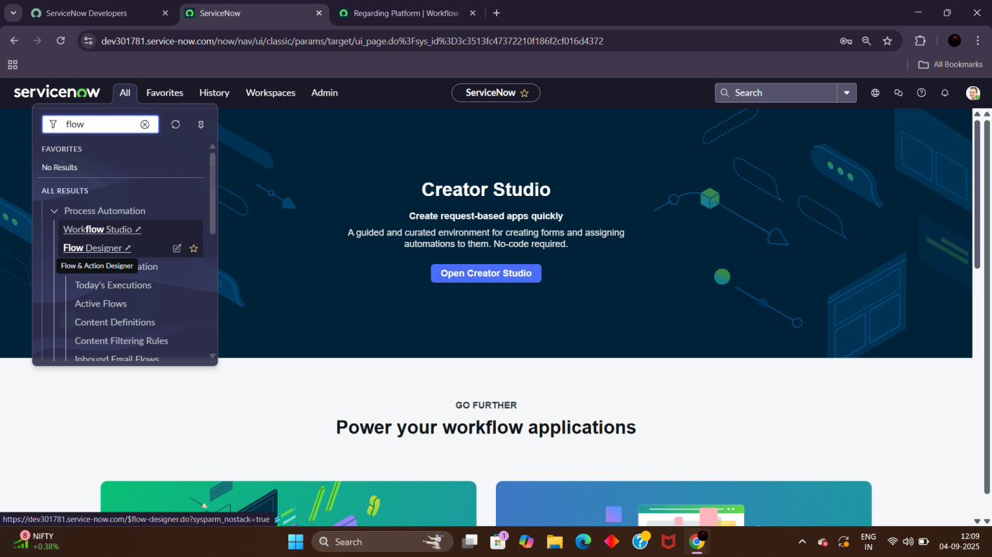

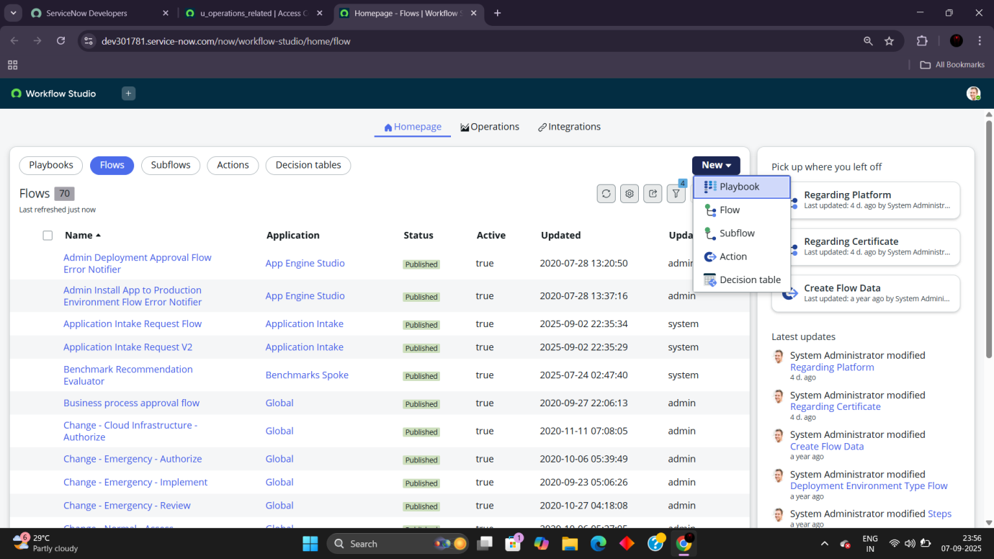

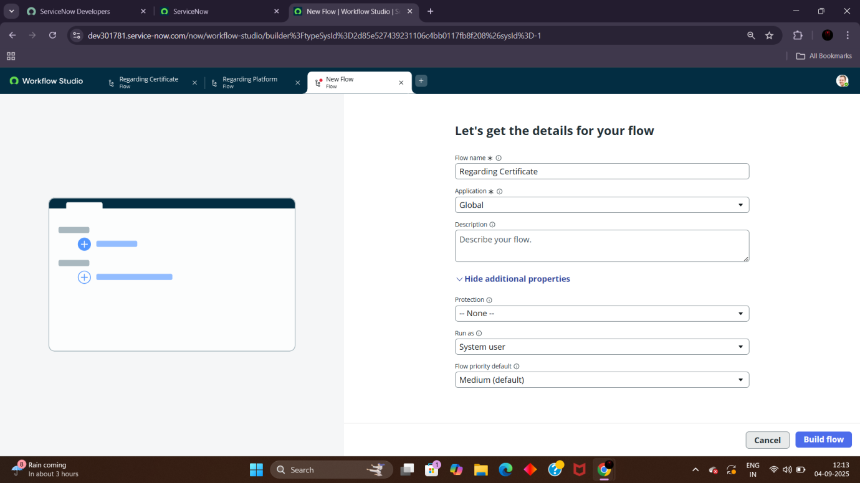

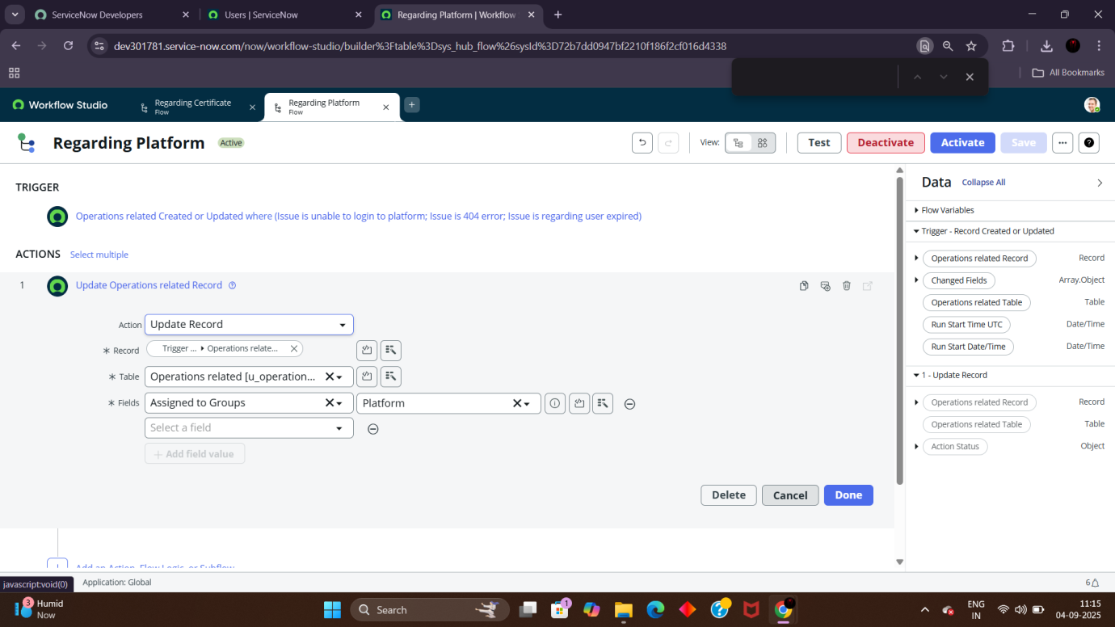

**Conclusion**

The implementation of the automated ticket routing system at ABC Corporation has been a significant success. By leveraging the capabilities of Service Now, we have streamlined the process of assigning support tickets to the appropriate teams, addressing the challenges of manual routing, and ensuring timely resolution of issues.